29. Write a C program to simulate the solution of Classical Process Synchronization Problem.

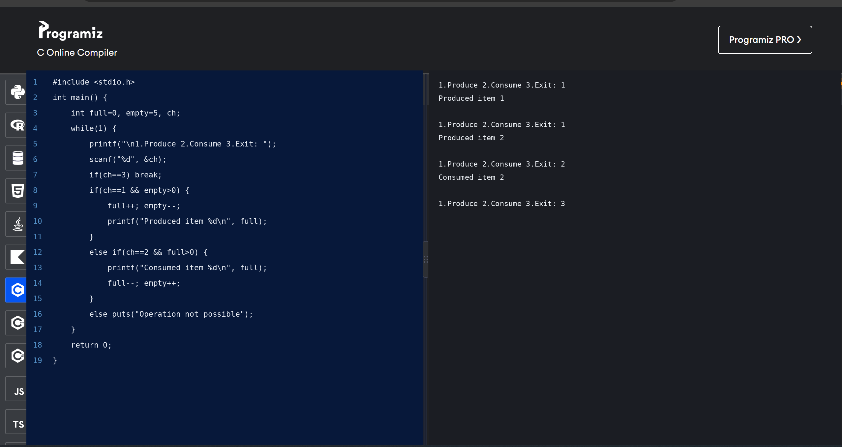

30. Write C programs to demonstrate the following thread related concepts.

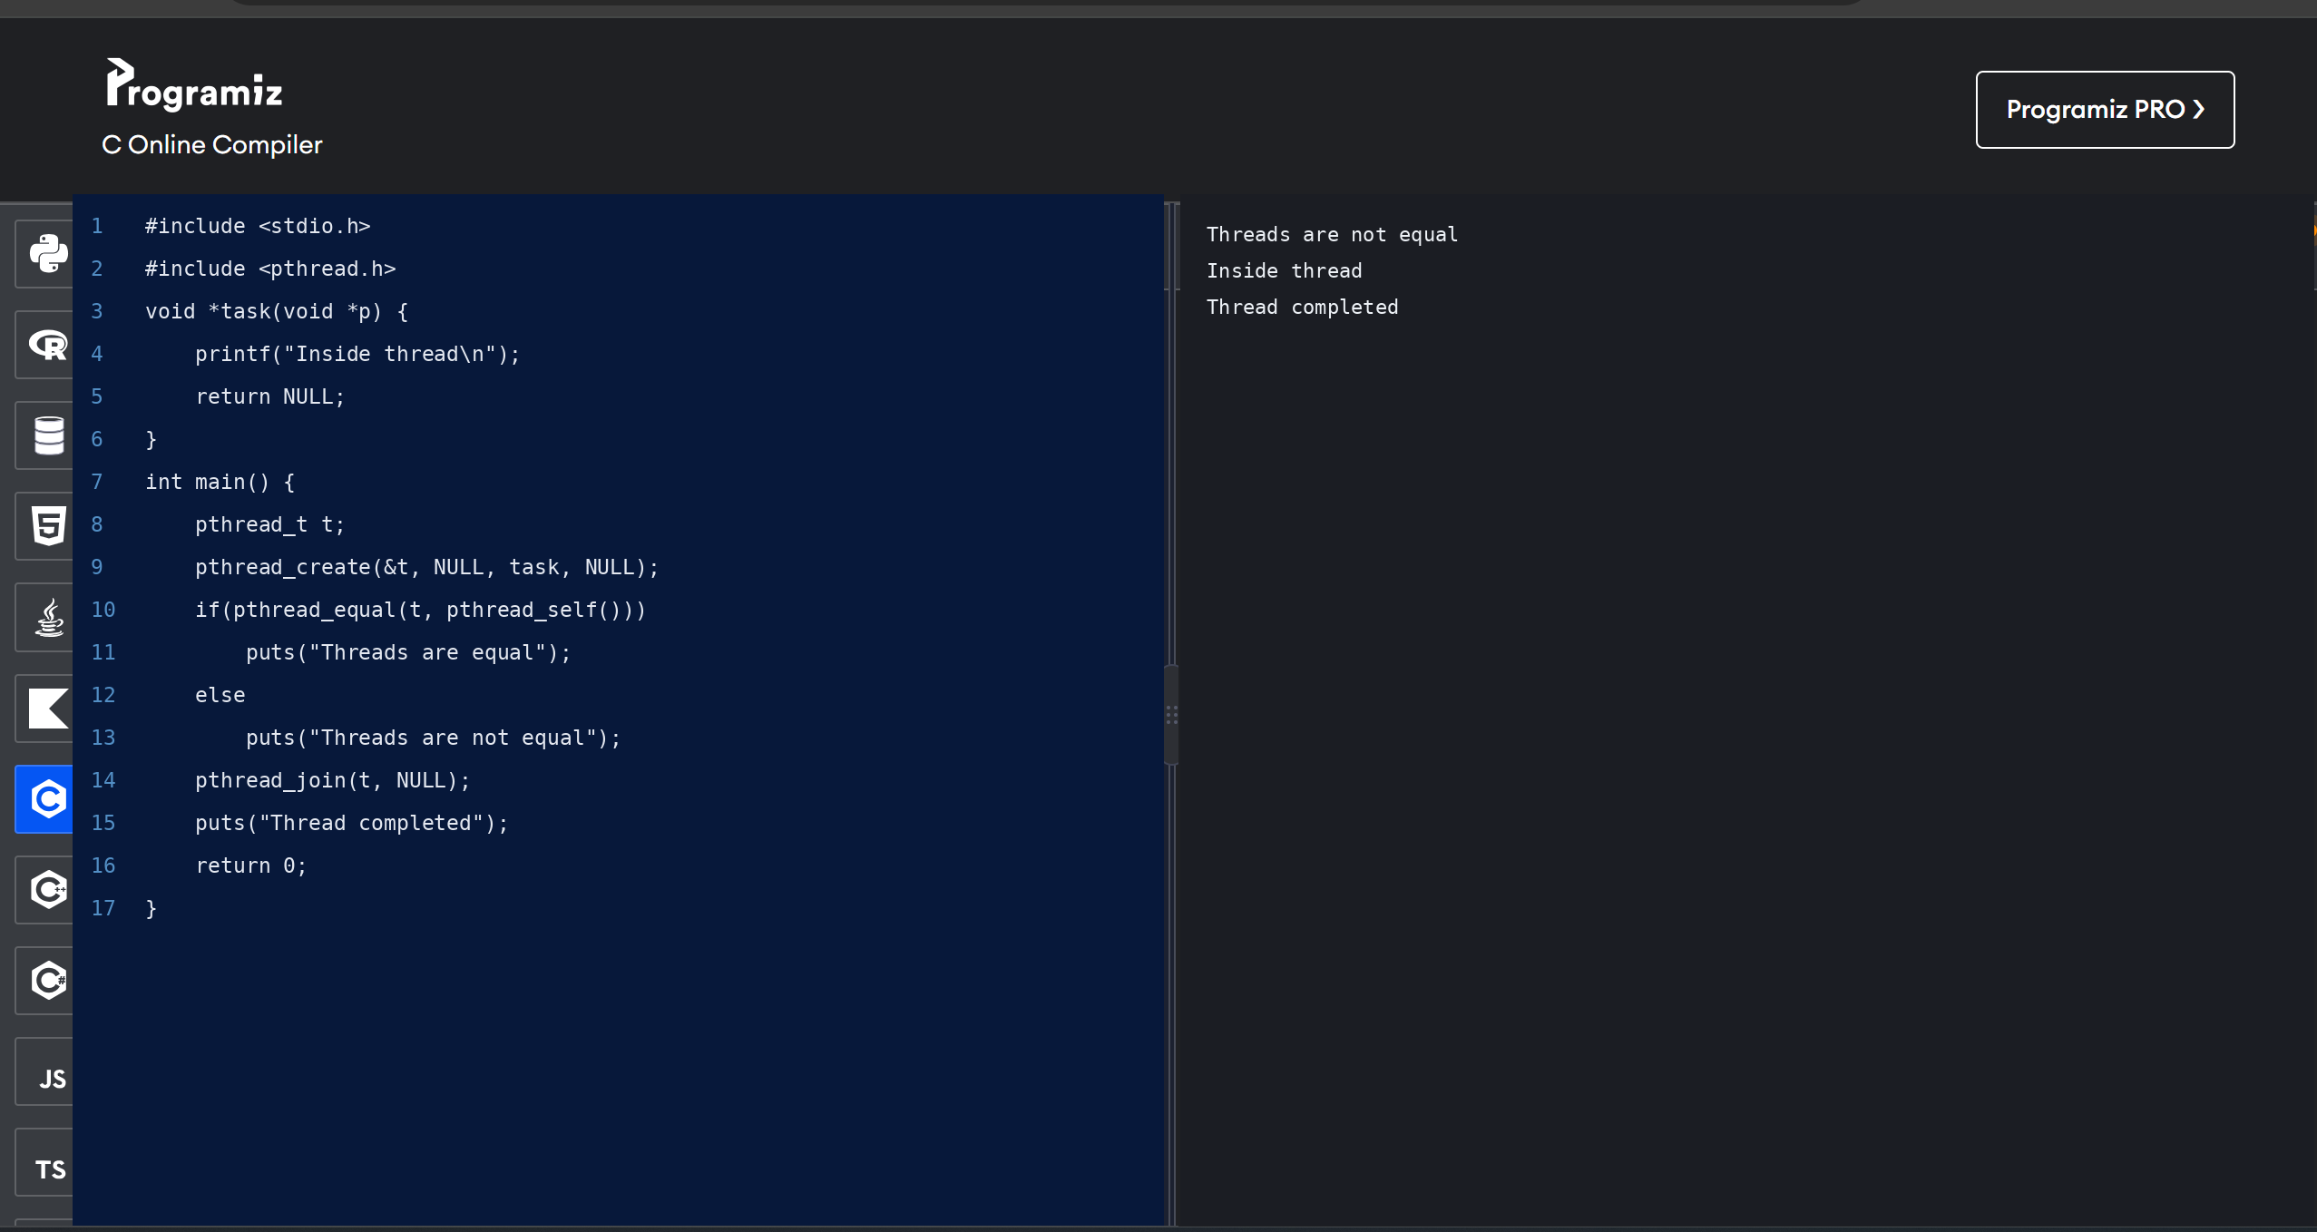

31. Construct a C program to simulate the First in First Out paging technique of memory management.

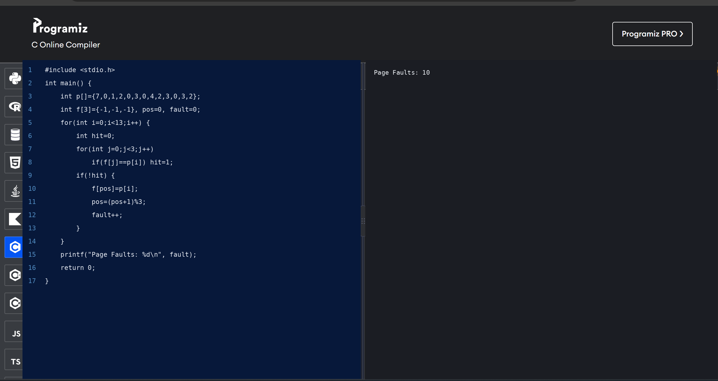

32. Construct a C program to simulate the Least Recently Used paging technique of memory management.

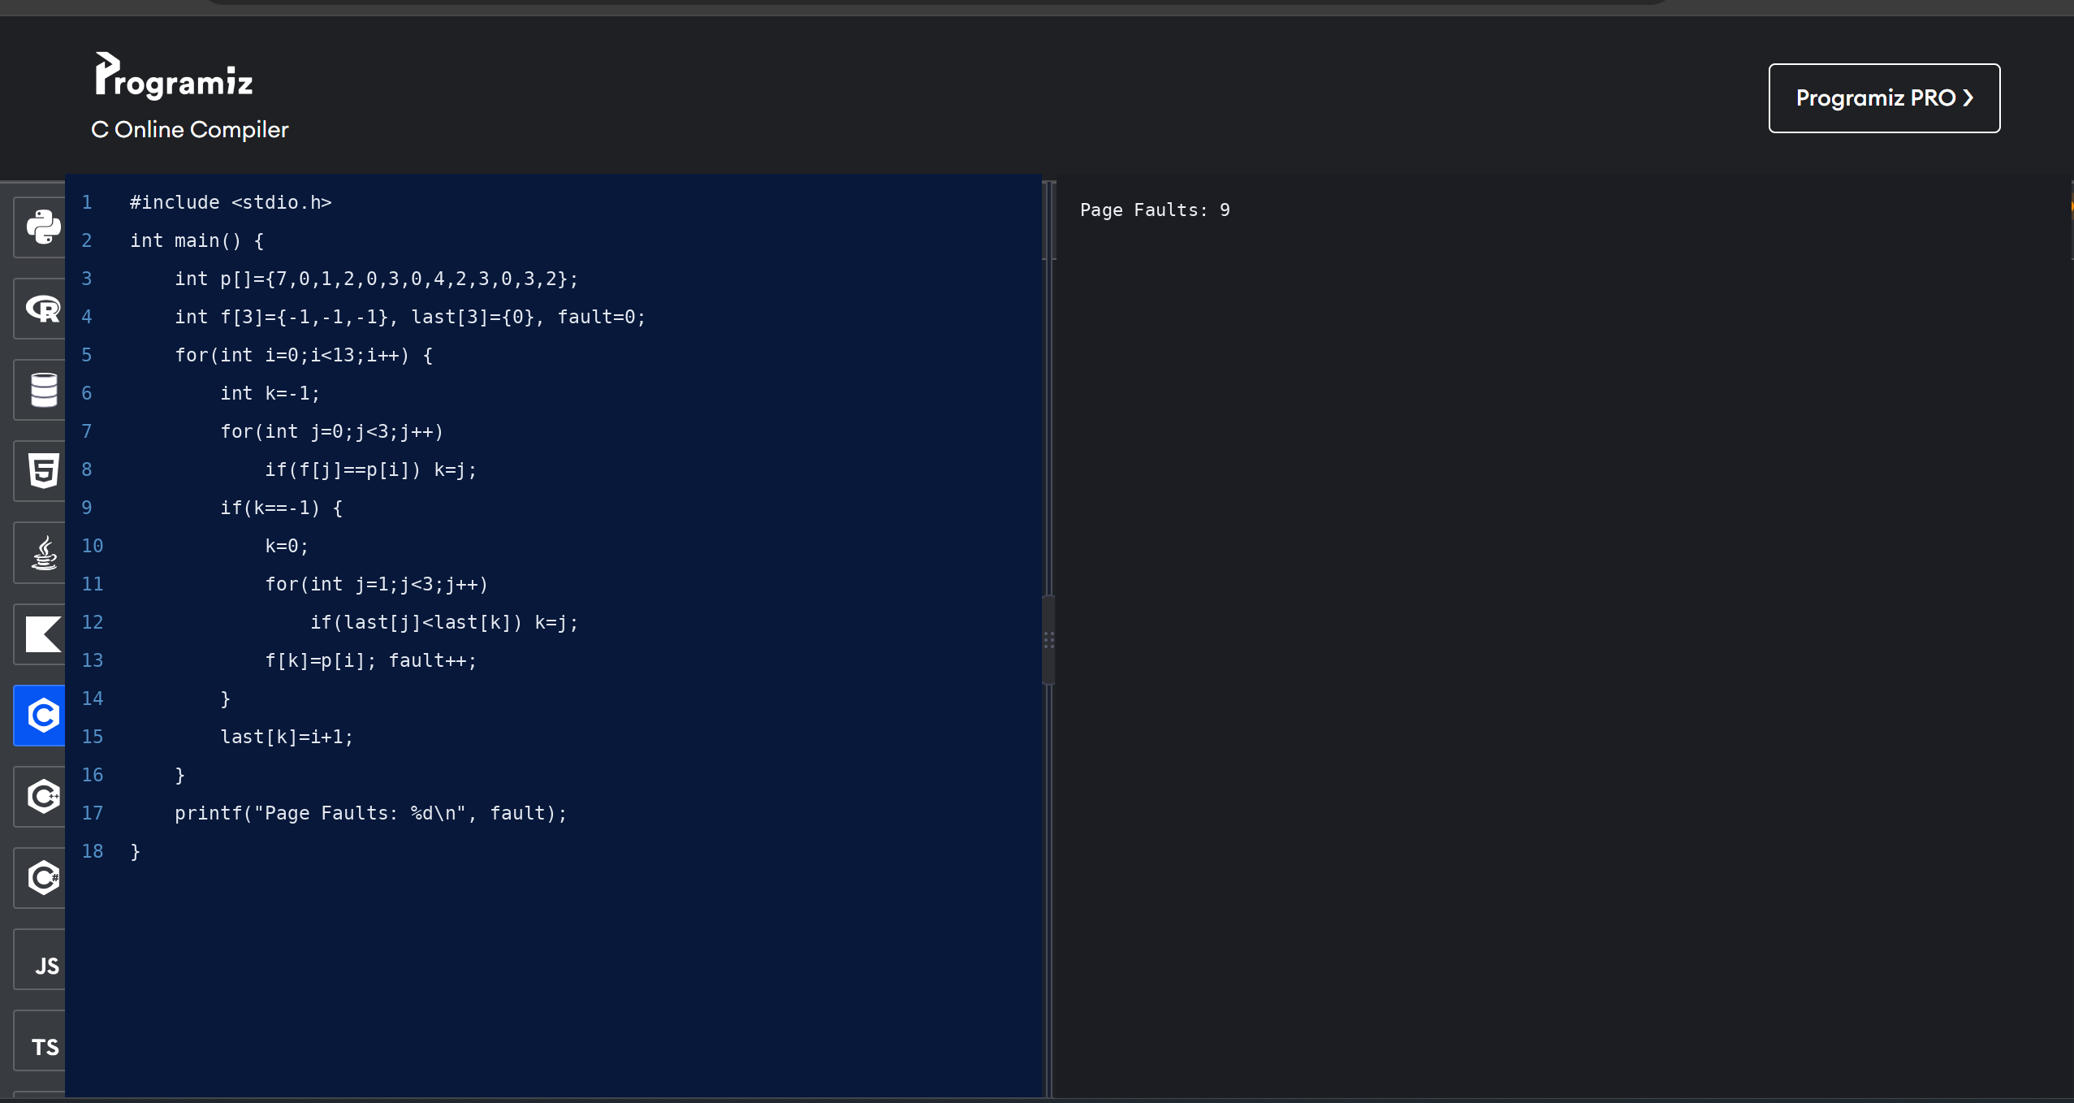

33. Construct a C program to simulate the optimal paging technique of memory management.

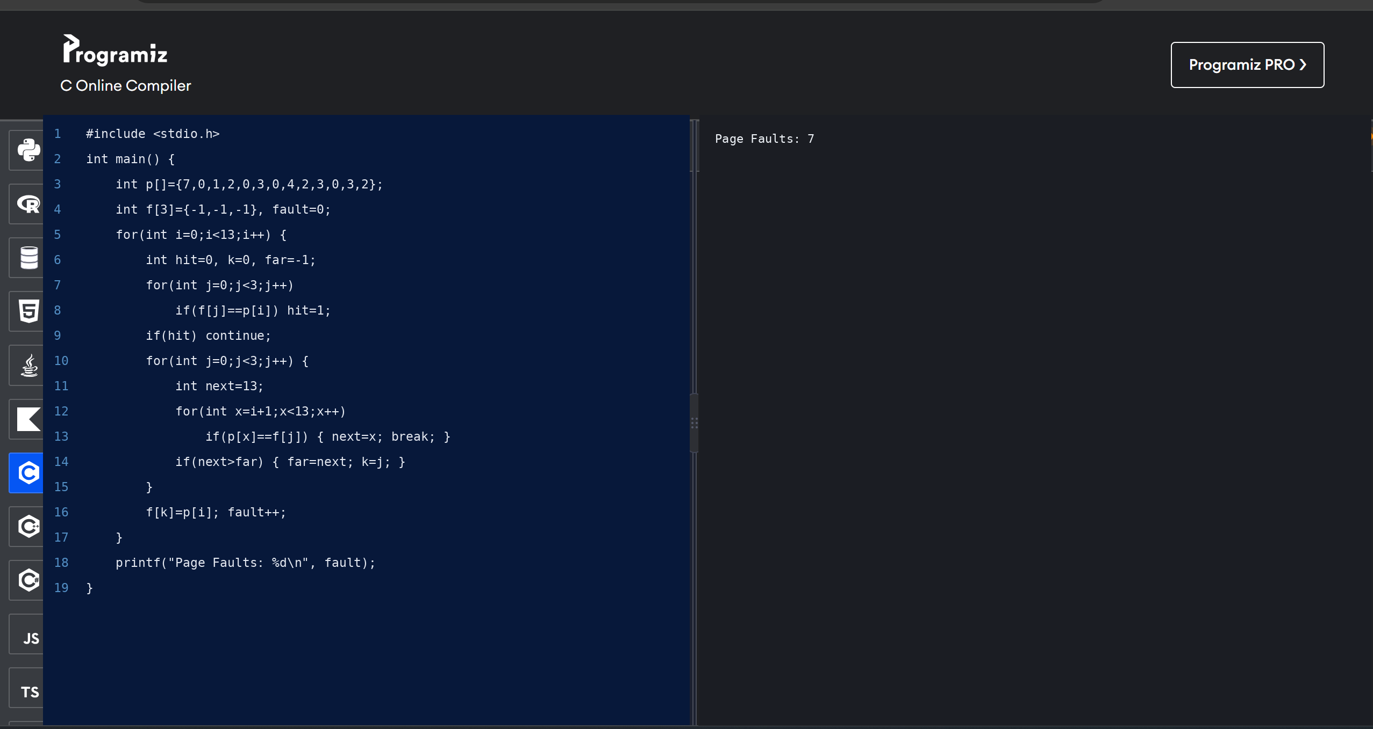

34. Consider a file system where the records of the file are stored one after another both physically and logically. A record can only be accessed by reading all previous records. Design a C program to simulate this file allocation strategy.

